1. Create role for lambda

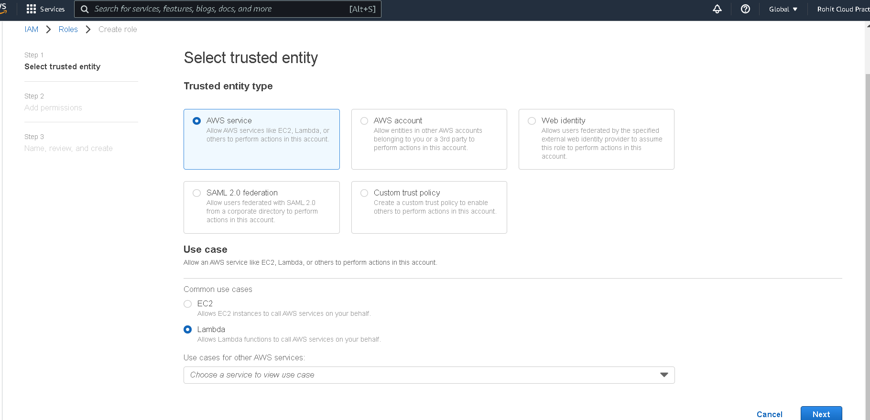

1. Publish new version after deployment or keep latest in setting.

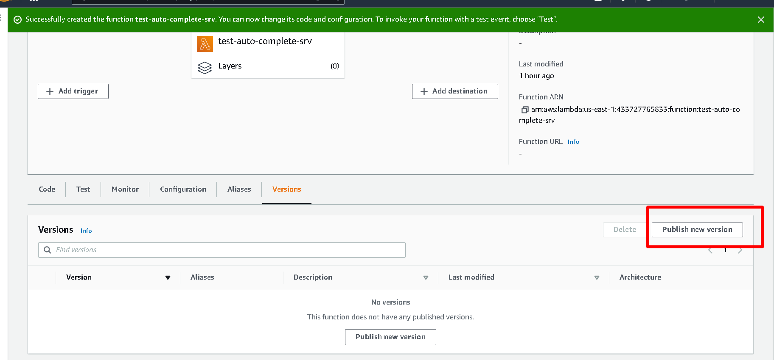

1. Creating alias if has more than one environment .

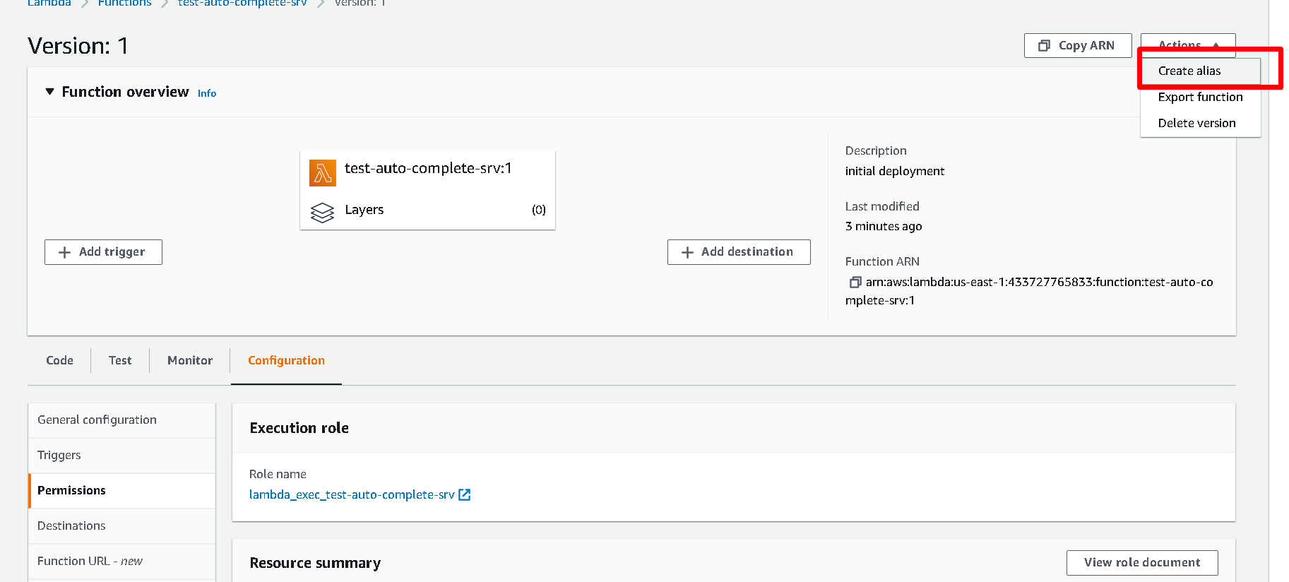

1. Create API gateway.

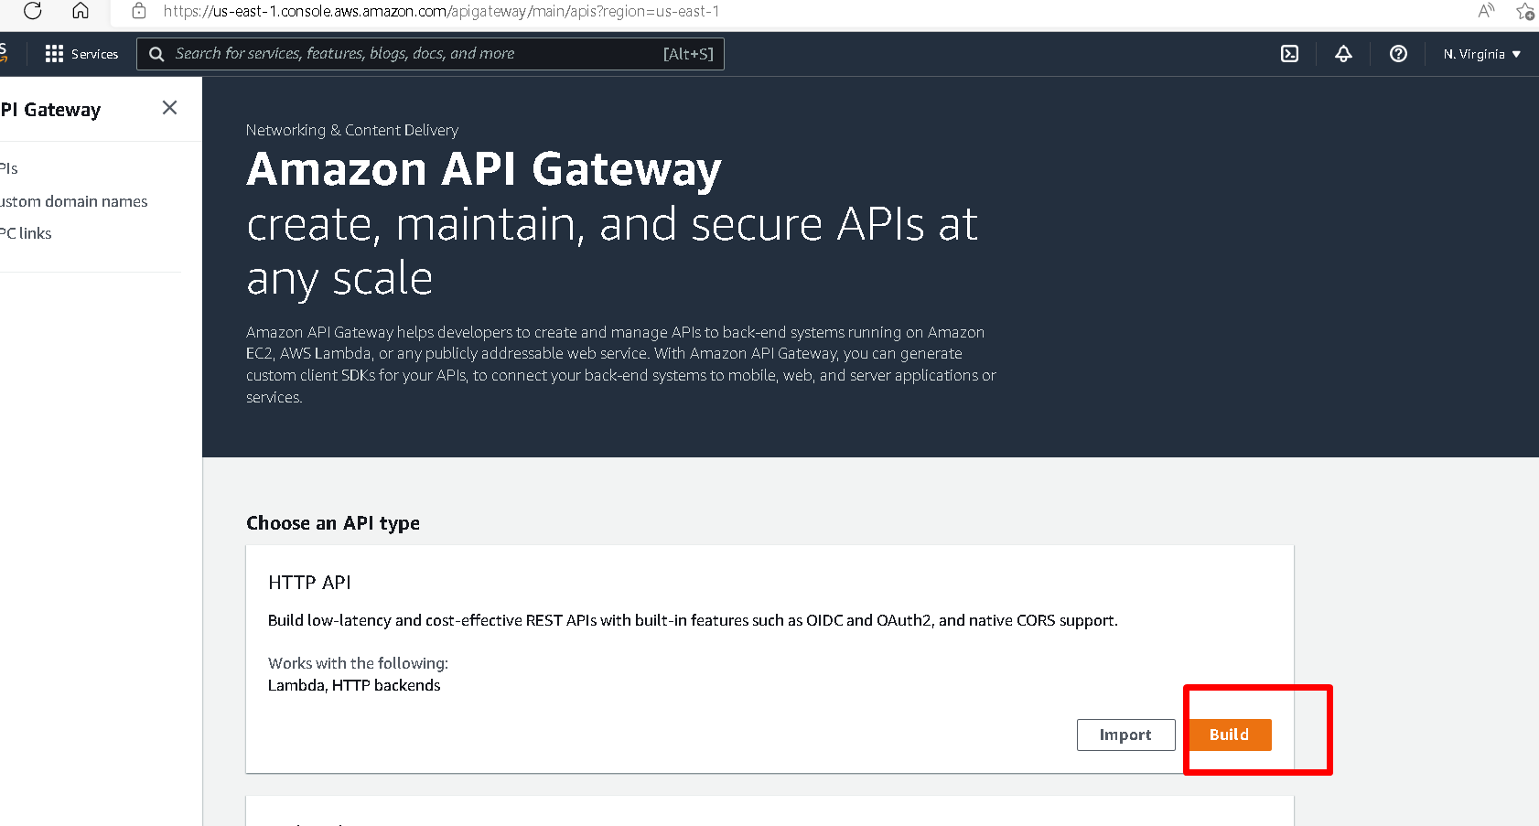

1. Create assing the lambda funciton arn .

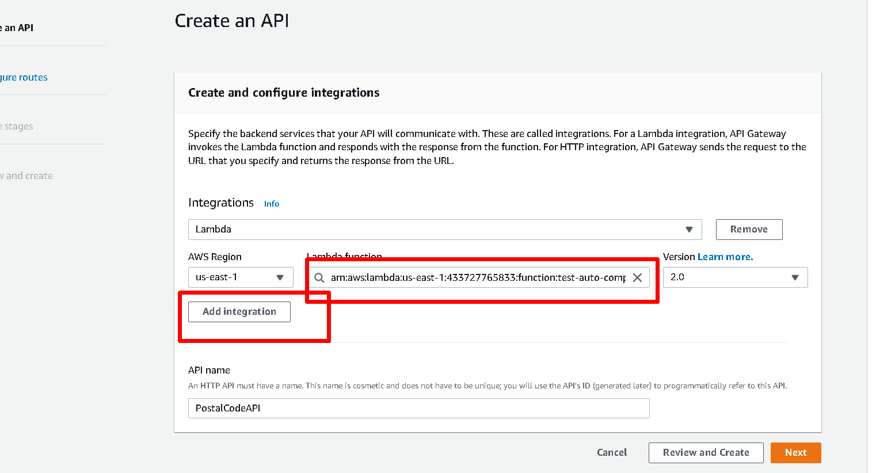

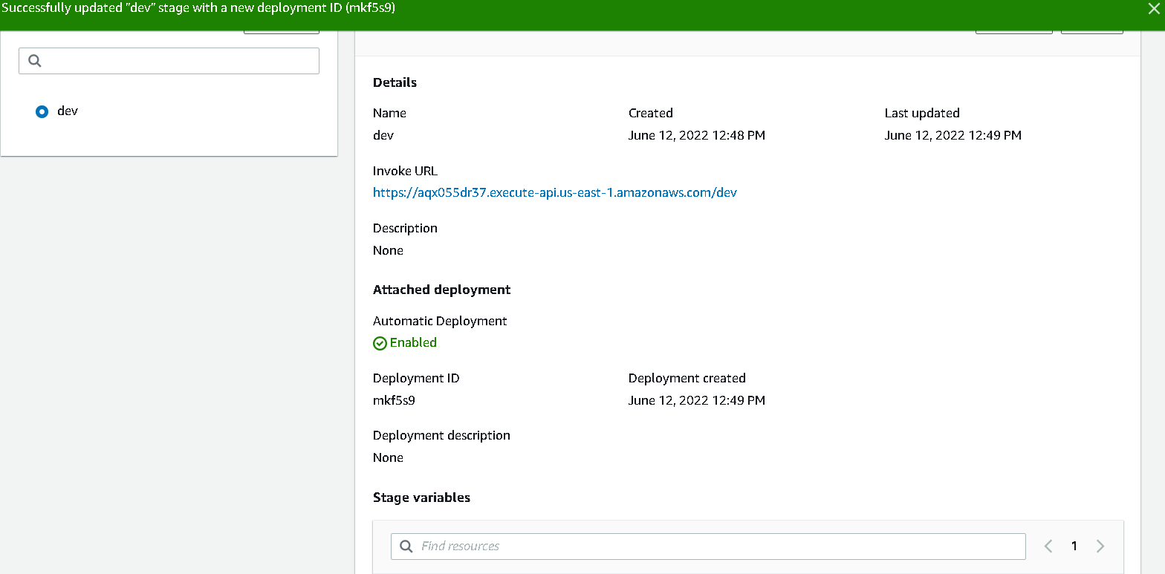

1. Request Parameter mapping for api route.

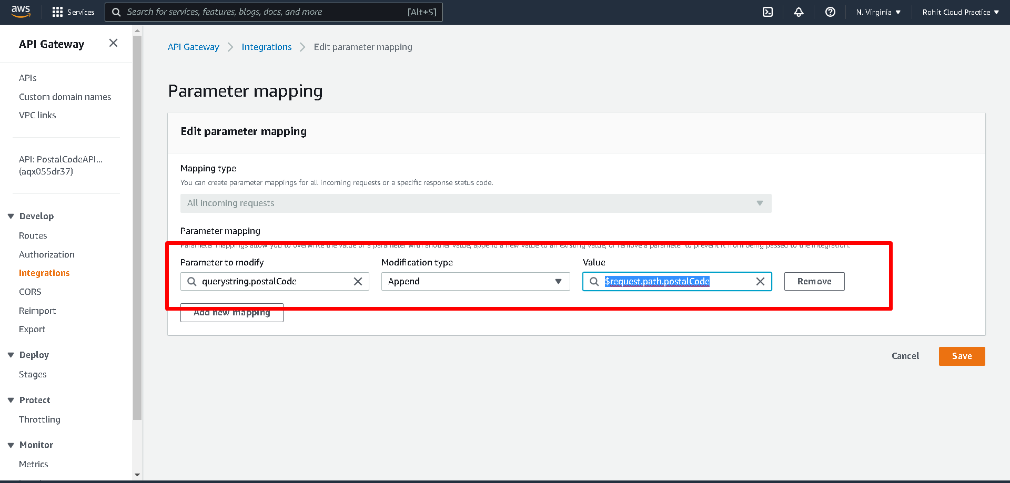

1. Creating Parameter store for maxLimite and Url

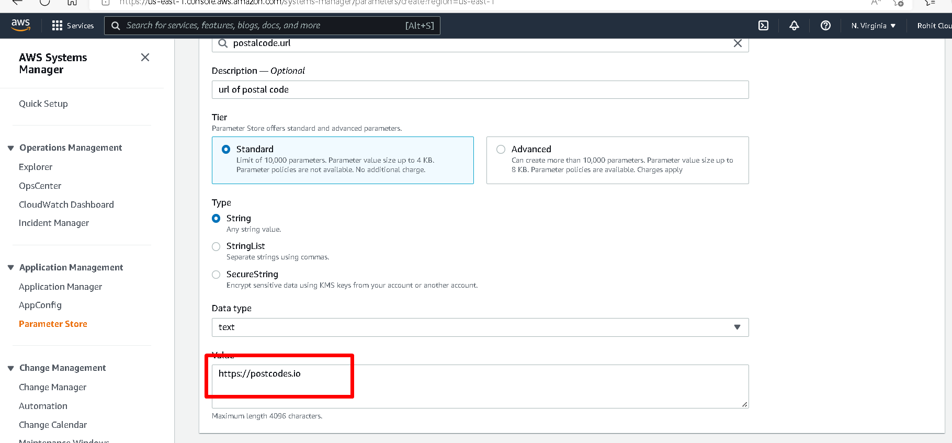

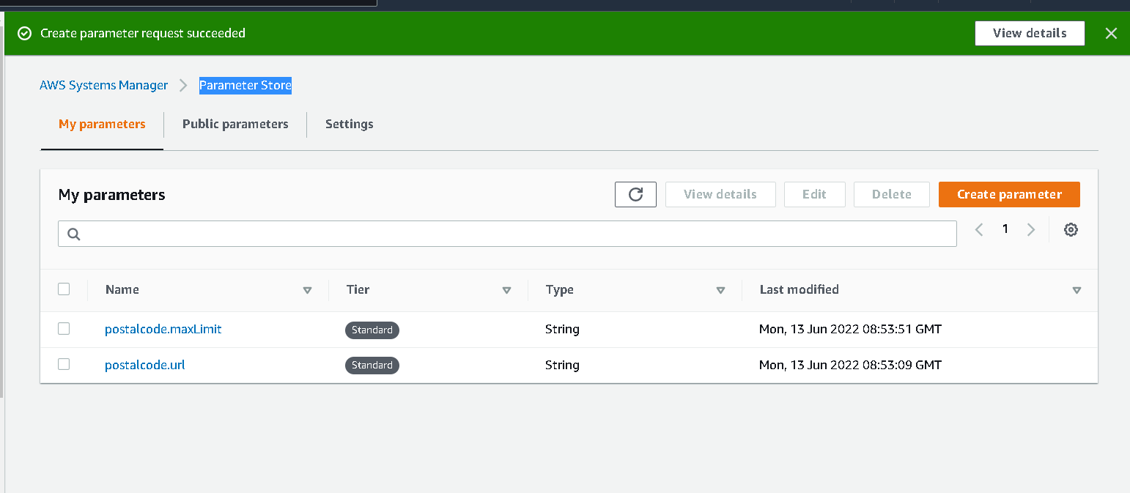

1. Parameter store policy need to be added.

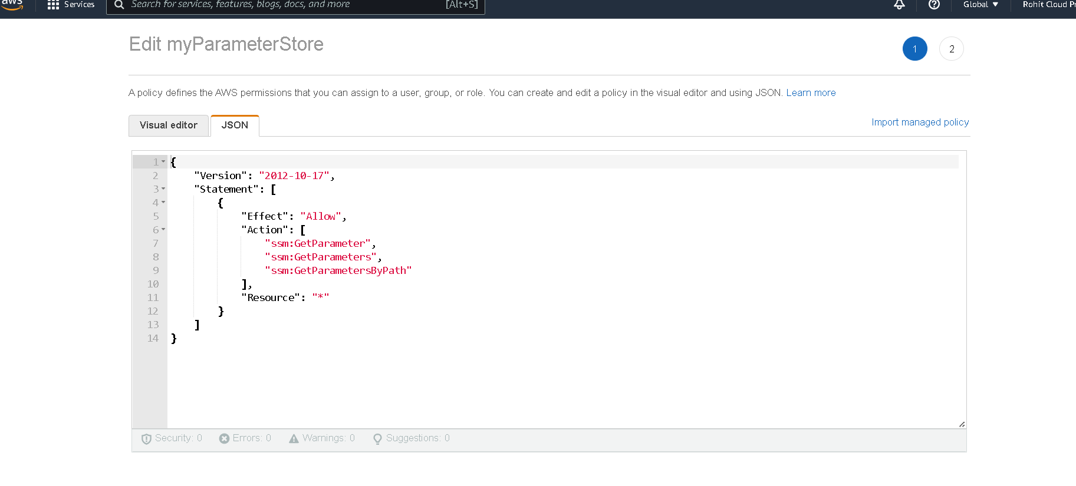

1. Create bucket and set the static site setting.

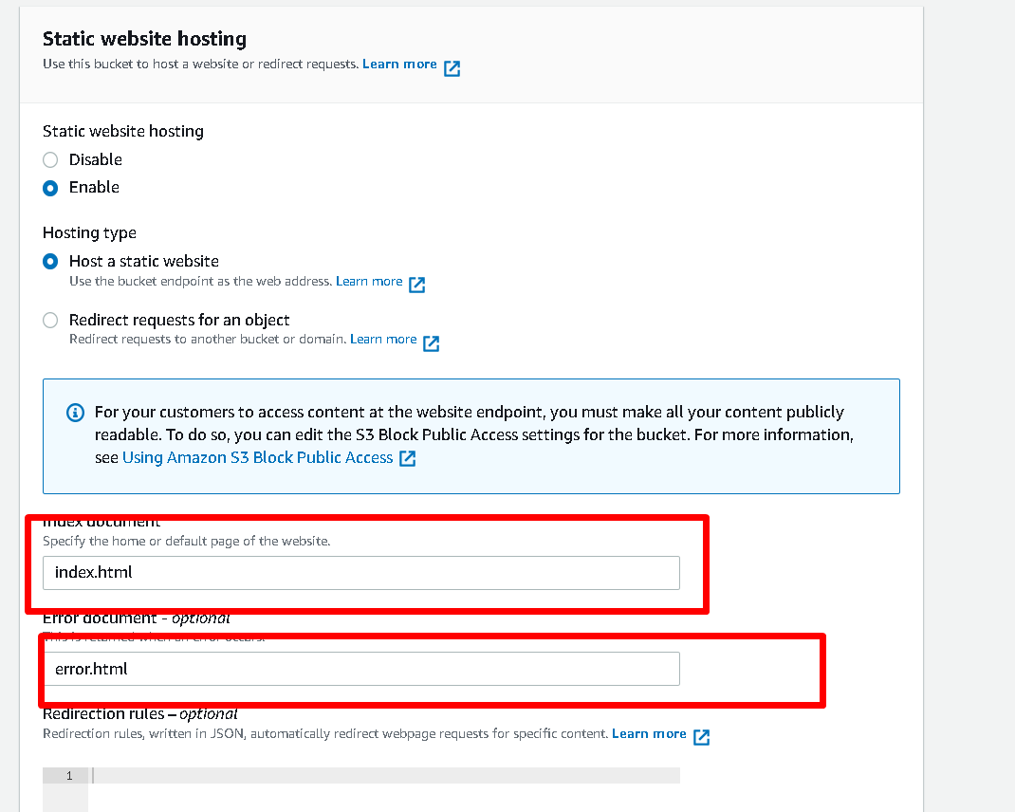

Lambda Project have two function and Libray

1) AutocompletePostalCode:

It takes search parameter and returns the list of postal code based based on maxima set in parameter store of aws.

2) PostalCodeDetails :

I takes postalCode as parameter and returns the details of postal code as mention in the document.

3) Service:

Its has all business logic and logic of fetching data from parameter store.

4) UI APP :

Its filters the postal Code by using API and returns the expected details